
  Roberta on the Arts
  Two Plays by Luigi Jannuzzi at Midtown International Theatre Festival 2007

  Home
  Contact Roberta
  Jazz and Cabaret Corner
  On Location with Roberta
  In the Galleries: Artists and Photographers
  Backstage with the Playwrights and Filmmakers
  Classical and Cultural Connections
  New CDs
  Arts and Education
  Upcoming Events
  Special Events
  Memorable Misadventures
  Mailbag
  Our Sponsors
  Two Plays by Luigi Jannuzzi at Midtown International Theatre Festival 2007
  - Backstage with the Playwrights
  
  Joseph Patelson Music House
  160 West 56th Street, New York, NY 10019
  212-582-5840
  www.patelson.com
  Midtown International Theatre Festival
  Eighth Season
  www.midtownfestival.org
  Exec. Producer: John Chatterton
  Assoc. Producer: Theater Resources Unlimited
  Managing Director: Emileena Pedigo
  Marketing Director: Bob Ost
  Press: Judd Hollander/Cynthia Leathers
  Festival Lighting Designer: Gustavo Araoz
  Venue Manager, Where Eagles Dare: Sarah Bellin
  Venue Manager, WorkShop Theatre: Jonathan Jackson
  Venue Manager, WorkShop Theatre: Stephanie Ward
  Box Office Managers: Jenny Greeman, Colleen Jasinski
  July 16, 2007-August 5, 2007
  Two Plays by Luigi Jannuzzi
  (Luigi Jannuzzi Website)
  All the King’s Women
  Produced and Written By Luigi Jannuzzi
  Co-Produced and Directed by Branan Whitehead
  Stage Manager: Lloyd Fass
  Featuring: Jessica Asch, Rebecca Bateman,
  Alisha Campbell, Craig Clary
  And
  Exhibit This! The Museum Comedies
  By Luigi Jannuzzi
  Directed by Elizabeth Rothan
  Featuring: Emily Beatty, Joseph Franchini, Dawn E. McGee,
  Jasmin Singer, Charles F. Wagner IV, Bruce Barton,
  Dustin C. Burrell, Billy Lane, Perryn Pomatto, Peter Stoll
  Dr. Roberta E. Zlokower
  August 6, 2007
  Luigi Jannuzzi is an inspiring, warm, and energized playwright, one who greets his audience as if they were guests in his home. He is eager to relate, both on a personal and professional level. His plays unfold in such an intimate and genuine way. Mr. Jannuzzi is an educator and producer, and he elevates thoughts to aesthetic realms in fresh and fascinating ways. He writes about Elvis Presley fans and Met Museum art with educated and unconventional twists.
  All the King’s Women is divided into eight vignettes. In each vignette, characters, mostly women, recall or discuss encounters with The King, in chronological order, from 1946 to the present day. Jannuzzi uses a static old radio as a prop to deliver timely news bulletins of the day between vignettes. Where Eagles Dare is a small, first floor theatre, and the up-front ambiance was well suited to the play’s dynamics. In the first vignette, Jessica Asch is a folksy saleswoman in a country store who sold Elvis his first guitar. (The actors’ Southern accents are well perfected). In “The Censor & The King”, Rebecca Bateman, Alisha Campbell, and Ms. Asch plan Elvis’ behavior and language, in view of an imminent appearance on the Ed Sullivan show. Another vignette related to Elvis’ meeting with Nixon, as three switchboard operators gush and gawk at the renowned guest’s arrival.
  In “Pink Cadillacs & God”, a car dealer (Craig Clary) and two saleswomen argue about who will or will not sell Elvis one more Cadillac. They debate the pros and cons of taking charge, in view of a potential loss or a successful sale. “Leaving Graceland” brings all four actors together for a humorous take on the crass commercialization of the Graceland trinkets, all well catalogued and packaged for eager tourists. The irony of this vignette is that Jannuzzi was prevented from using Elvis Presley’s likeness or music at any point in this well-conceived production, because of the excusive rights of Elvis’ estate. The lack of Elvis’ iconic music was a true disappointment, as I was an original Elvis fan and had been eager for a show about this star. The music would have added zest and personality to the imagery of the unseen singer. There was no Elvis character. However, Jannuzzi worked with his biographical and dramatic material with smooth transitions and captivating creativity.
  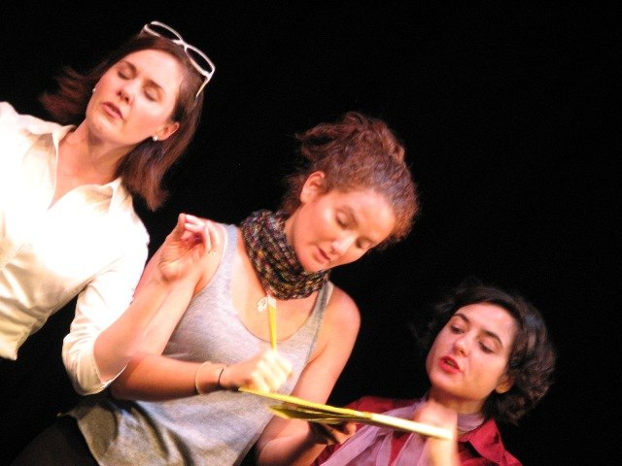
  Alisha Campbell, Jessica Asch, Rebecca Bateman in ALL THE KING'S WOMEN
  Photo courtesy of Luigi Jannuzzi
  Exhibit This! The Museum Comedies is a clever series of vignettes, much like All the King’s Women, only, in this case, Jannuzzi apparently had the Met Museum’s permission to use slides or likenesses of 26 paintings, sculptures, or mummies. But, where the Presley play had eight vignettes, the Met play had six plays and six monologues, a lot for one sitting. Yet, the art works were presented and personified with such knowledge and humor that it was thoroughly delightful to experience this production. There were portrait paintings (1877 and 1919) that fought and flirted with each other and their artists, mummies embalmed and mummies of bones of 2350 BC that feared storage and cats, characters in Seurat’s 1885 “A Sunday of La Grande Jatte” who literally escaped, and an 18th century Watteau musician who was dynamic and devilish.
  Centuries disappeared between vignettes, much as decades disappeared between vignettes in All the King’s Women. African sculptures dance in contemporary rhythms, and Socrates has a cell phone. The tour guide, Jasmin Singer, is on the mark, witty and faux esoteric. The actors personify these visual characters from the art world with nuance and texture. Luigi Jannuzzi is a playwright to watch.
  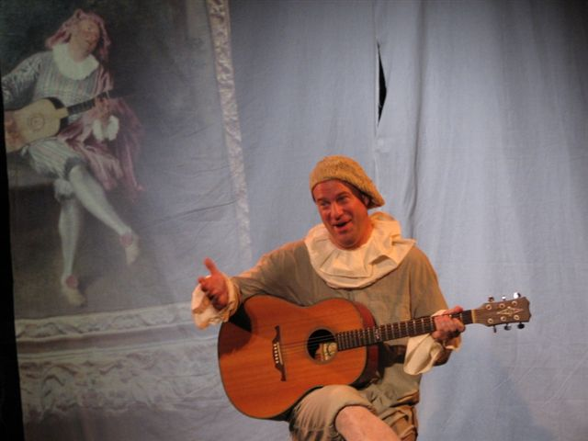
  Bruce Barton in EXHIBIT THIS! - THE MUSEUM COMEDIES
  Photo courtesy of Luigi Jannuzzi
  Ticket Solutions sells the best of Jersey Boys tickets, Wicked tickets, Mary Poppins tickets, The Color Purple tickets, Deuce tickets, Phantom of the Opera tickets, Curtains tickets, Avenue Q tickets, Lovemusik tickets, and Spamalot tickets. Ticket Solutions is the source for all premium Broadway tickets in New York and premium New York concert tickets!
  For more information, contact Dr. Roberta E. Zlokower at zlokower@bestweb.net

